House Hunt — Solution Architecture
How the platform's components fit together
House Hunt follows a classic three-tier MERN architecture: a React single-page application on the client, an Express.js REST API implementing MVC on the server, and a MongoDB document database. This document describes the structure of that architecture and the technology backing each layer.

Architecture Diagram

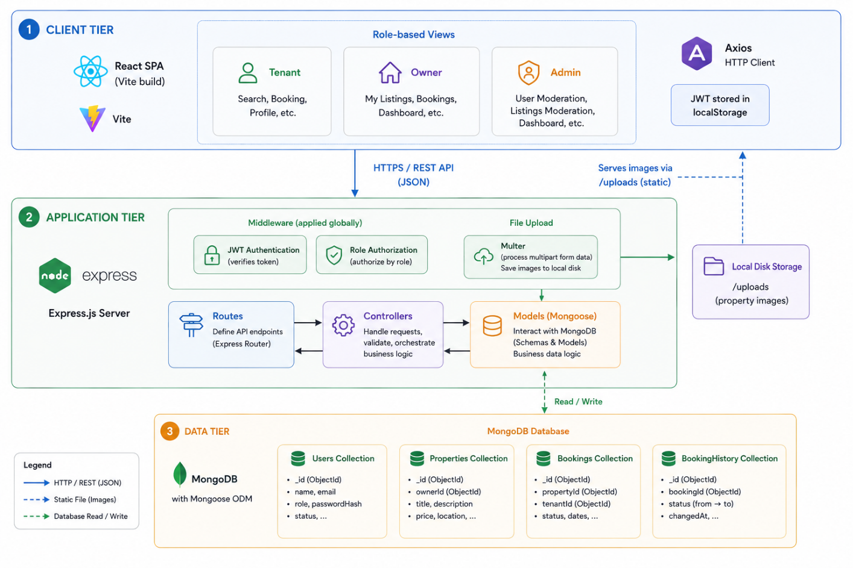

Layer-by-Layer Breakdown

Client Tier
A single React application (built with Vite) serves all three roles from one codebase. React Router handles navigation between public pages (home, listings, login/register) and role-gated dashboards (Tenant search/bookings, Owner listing management, Admin moderation). Axios, with a shared instance and request interceptor, attaches the JWT to every authenticated call. Styling is handled through Bootstrap and MUI components with Framer Motion for transitions, giving a consistent dark-themed interface across roles.

Application Tier
The Express.js server is organized by MVC convention: routes define endpoints, controllers contain business logic (registration, search/filter queries, booking state transitions, approval workflows), and Mongoose models define schema and validation. Two custom middleware layers guard the API: an authentication middleware that verifies the JWT and attaches the current user to the request, and an authorization middleware that checks the user's role (Tenant/Owner/Admin) and, for Owners, whether their account has been approved. Multer handles multipart image uploads for property listings, validating file type and size before writing to local disk storage.

Data Tier
MongoDB stores four core collections: Users (Tenant/Owner/Admin accounts, credentials, profile data, approval status), Properties (listing details, amenities, images, owner reference, availability status), Bookings (rental requests with dates and status), and BookingHistory (a log of property views and booking actions per tenant, powering the "My History" feature). Mongoose enforces schema-level constraints (required fields, enums for roles/status) as an additional validation layer beyond the controllers.

Key Architectural Decisions
- Stateless authentication (JWT) rather than server-side sessions — simplifies horizontal scaling of the API layer, since no session store needs to be shared across instances.
- Local disk storage for images via Multer rather than a cloud storage service — keeps the stack simple for the current scope, with the trade-off that a persistent volume is required if deployed to an ephemeral-filesystem host.
- Single unified codebase for all three roles rather than separate applications — reduces duplication of shared logic (auth, property schema, API client) at the cost of slightly more complex role-based routing on the frontend.
- Owner-approval gate implemented as a boolean flag checked by middleware, rather than a separate verification service — keeps the trust mechanism lightweight and fully within the existing MVC structure.

